2.4.1 Continuity

Motivation: We want to call a function continuous if we can draw the graph of the function without picking up our writing utensil.

We now present a rigorous definition of continuity of a function at a point.

Definition: A function is continuous at a number a if .

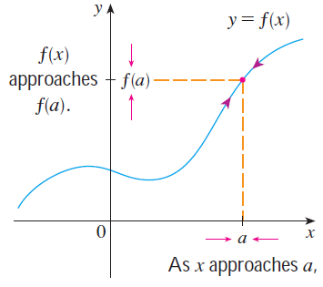
Note: It is very important to note that if one or both sides of the equation defining continuity does not exist, then the function is NOT continuous at a! For example, if the limit is infinite, the function is not continuous at a.

The following picture illustrates the definition of continuity above:

Example 1: The function is pictured below. Would you say that is continuous at 5?

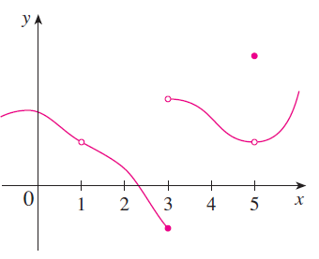

Question: What are all of the values of x at which the function
is discontinuous?

Example 2: State whether the following function is continuous at 1. Explain your answer.

Example 3: Prove that the function is continuous 5.

Types of Discontinuities

Removable Discontinuities | Infinite Discontinuities | Jump Discontinuities

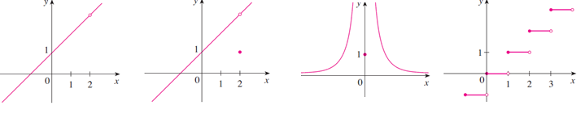
Example 4: Find all the real numbers at which the following function is discontinuous. Also state the type of discontinuity at each number that you find: .

Example 5: Answer each of the following.
- Give an example of a function with an infinite discontinuity at 4.

- Give an example of a function with a removable discontinuity at 4.

We now introduce some definitions to help us make sense of statements like: “f is continuous on an open/closed interval”.
Definition: A function f is continuous from the right at a if , and f is continuous from the left at a if .

Definitions:
- A function f is continuous on the open interval (a,b) if f is continuous at each number in the interval.
- A function f is continuous on the closed interval [a,b] if the following three conditions hold:
- f is continuous on (a,b)
- f is continuous from the right at a.
- f is continuous from the left at b.

Example 6: Consider the function . The graph of the function is below:
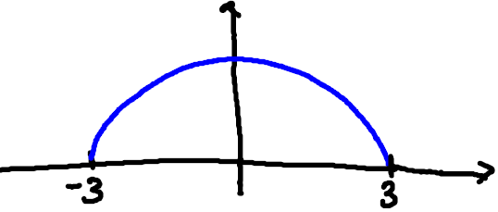

- State the domain of f.

- Show that is continuous on its domain.

We now present two theorems which will help us determine when functions that we are familiar with from Precalculus are continuous.
Theorem: If and are continuous at a and c is constant, then the following functions are also continuous at a:
- 2. 3.

4. 5. if
Proof (of 1):

Note: The proof of statements 2, 3, 4, and 5 are similar to the proof of statement 1.
Theorem: The following types of functions are continuous at every number in their domains.

- Polynomial Functions
- Rational Functions
- Root Functions
- Trigonometric Functions
- Inverse Trigonometric Functions
- Exponential Functions
- Logarithmic Functions

Example 7: Use the two most recent theorems to determine where the function: is continuous.

Example 8: Find a value of C that makes g continuous on .

Example 9: Consider the function: .
- State where this function is continuous.

- Evaluate (be exact).

Note: We are more or less using a generalization of the direct substitution property from section 2.3.1 in (b). In particular, if we are trying to find , and we know that f is continuous at a, then the limit can be found by simply plugging a in for x (i.e. finding ).

Question to the Class: How might you approach evaluating the limit: ?

Theorem: If is continuous at b and , then .

Note: The theorem above immediately implies that if g is continuous at a and f is continuous at g(a), then is continuous at a as well.

Example 10: We can use the theorem above to evaluate the limit mentioned in the question above. Specifically,

Example 11 (if time permits): Where is the function continuous?

